Preschoolers have better long-term memory for rhyming text than adults

SUPPLEMENTAL MATERIALS
SUPPLEMENTAL MATERIALS

1. Example video recording of free-recall (of verse) tests.
Please see Supplemental Movie 1 for a recording from a child participant.

2. The potential role of overall verbal competencies on verbatim recall performance
To address the potential role of overall verbal competencies of Children on verbatim recall performance, we investigated the possible association between recall performance and receptive vocabulary.
The Hungarian adaptation of the Peabody Picture Vocabulary Test was used to assess Children’s receptive vocabulary. In this test, Children were given a word and their task was to choose the picture that represents the word out of four options. The testing session ended when the child was unable to define 6 out of 8 pictures. The final score is the total number of correctly chosen pictures. On the Peabody Picture Vocabulary Test (following Hungarian standards, see Csányi, 1976) 9 out of 14 Children had ‘average’ (range: 46-71) and 5 had ‘developed’ (72 or above) receptive vocabulary scores (mean = 67.8; SD = 9.8). The correlations between PPVT scores and verse recall, and between PPVT scores and verse error were not significant (r = 0.156, p = 0.593; r = -0.108, p = 0.714, respectively).
Additionally, we investigated the association between the socio-economic status (SES) of families and performance on verbatim recall. There was no significant correlation between the SES scores of Children and verse recall or verse error (r = -0,122, p = 0.679; r = -0.188, p = 0.519, respectively). Similarly for Parents, we found no significant correlations between SES and verse recall or verse error (r = -0.133, p = 0.666; r = -0.281, p = 0.352, respectively).

3. Exploring the effects of prompts on verbatim recall
When a participant got stuck during free recall of the verse, the experimenter offered a prompt, i.e. revealed the next word. Our analysis, reported in the main text, showed that the factor of prompts was not needed to account for group differences in recall performance. Here we describe finer-grained tests to see what effect prompting may have had on recall, if any. First (within a group) we determined the frequency with which each word was recalled, and the frequency with which the word just prior was prompted. We can then see whether there was a correlation between recall performance on a particular word and the number of prompts the previous word received, i.e. whether participants were more likely, in general, to recall words that followed prompts. The correlations were not statistically significant for any of the groups (r = -0.12, p = 0.12; r = -0.08, p = 0.31; and r = -0.01, p = 0.90, for Children, Parents, and Young Adults, respectively).
Next, we compared recall performance between groups as we did in our main analysis reported in the text, but now computed over just those words where the preceding word was never prompted; a more apples-to-apples comparison. Here, performance showed the same pattern as our main results, with Children outperforming both Parents and Young Adults (71% percent recalled by the children vs. 52% and 44% for the parent and adult student groups, respectively. This is nearly identical to our main result that showed 70% correct recall for Children, versus 52% and 42% for the Parents and Young Adults, respectively).
Finally, we looked at performance on the first word of each line of the verse. This isolated a set of words that was 1) identical for all three groups, 2) occupied the same position in the verse, and 3) that never had a preceding prompt. This is the most ‘level playing field’ comparison to be made. Again, the pattern of results was the same as in our main analysis (albeit with lower performance overall since all groups show poorer performance on the first word of any line: 52% percent correctly recalled by the Children vs. 44% and 33% for the Parent and Young Adult groups, respectively). Put together, it seems that prompts do not have any obvious, lingering effect on recall, and the main pattern of results holds true even in contexts within the verse where prompting did not occur.

4. Visualizing differences in recall performance between Children and Young Adults.
For the reader’s interest and to further aid visualization of our results, in Figure S1 we offer a ‘heat map’ contrasting verse recall for Children versus Young Adults. This is the most informative comparison, as these groups were both presented with the verse orally (i.e. passive listening), did not have visual access to the text during presentation or test, and did not have significant differences in prompts, intrusive vs. confusion errors, gist recall, or list recall – and yet et had the largest differences in our main measures, verse recall and verse error). This visualization supports the results presented in Figure 3 in the main text. While it is clear that there is a general, pervasive advantage of Children over Young Adults, the advantage is especially prominent for words that appear later in lines. As discussed in the main text, these are the words more constrained by the rhythm and rhyme of preceding words. This is consistent with children’s advantage being one for verse, per se.

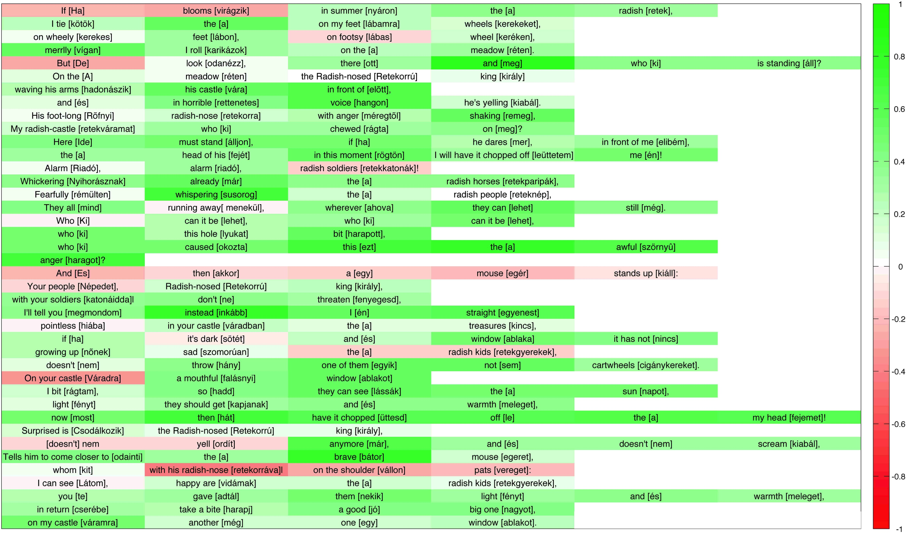
Fig. S1. Heatmap contrasting Children’s performance to that of Young Adults at free recall of the rhyming verse. Each cell in the heatmap shows a word from the verse in Hungarian, with an English translation. The color of the cell reflects the difference in average verse recall (expressed here as a proportion, i.e. the proportion of times the particular word was recalled) for Children as compared to Young Adults. This produces a scale that runs from 1.0 (which would mean Children recalled the word in question 100% of the time, and Young Adults 0%; shaded green) to -1.0 (meaning Young Adults always recalled the word and Children never did; shaded red).

5. Supporting results from pilot and follow-up studies
Eleven child-parent pairs had participated in an earlier, pilot study (children: mean age = 4;8 years, SD = 7 months, age range: 3;12 – 5;3 years, 7 females, parents: mean age = 37;7 years, SD = 1 year, age range: 31 – 48 years, 9 females). As with the experiments reported in the main text, all data was collected in accordance with relevant ethical guidelines and regulations and the approval of the Ethical Committee of the Faculty of Education and Psychology, Eotvos Lorand University. Adults gave informed consent prior to participation; children assent.
Procedures were the same as in our main experiment reported in the text, but here only Children were given prompts and Parents were not told ahead of time that they would be tested at the end of the sessions. We found the same main effect using a univariate ANOVA as in our main experiment: Children’s free verbatim recall performance was significantly higher than Parents’: verse recall: F(1, 20) = 8.371, p = 0.009, η2 = 0.295, error rate: F(1, 20) = 16.56, p = 0.001, η2 = 0.415).
In a separate follow-up study, we tested a new Young Adult group of 15 University students. Procedures matched those in our main experiment exactly, except these participants were given even more explicit, motivating instructions. They were made fully aware of the nature of the experiment: This was a test of their memory, and they would have ten days, ten exposures, to learn a verse, and then perform a verbatim free recall on the 11th day. A website was created where they had to log the time they listened to the verse each day, and every day they were sent a reminder to complete their study session and record their compliance. Ten Young Adults (mean age = 23;10 years, SD = 2;2 years, age range: 21-29 years, 6 females) met our strict controls and completed the sessions. We added the data of this new Young Adult group (verse recall mean: 55.9; SD=45.3) as a separate forth group to an analysis of a univariate ANOVA, where we found the same main effect of verse recall as in the reported main experiment (F(3, 46) = 6.478, p = 0.001, η2 = 0.297). Post hoc analyses revealed that the performance of the highly controlled Young Adults group differed only from the verbatim recall performance of Children (Bonferroni corrected p = 0.001), and not at all from any of the other adult groups (Parents: Bonferroni corrected p = 0.303; original Young Adults Bonferroni corrected p = 1.000). In sum, these results confirm those reported in the main text: 4-year-olds outperform adults, by nearly a factor of two, in free recall of rhyming verse.

6. The Radish-nosed King, by Aliz Mosonyi.
(Translated from Hungarian by author ZK. Hungarian has an AABB rhyming scheme.)

Ha virágzik nyáron a retek,
kötök a lábamra kerekeket,
kerekes lábon, lábas keréken,
vígan karikázok a réten.

De odanézz, ott meg ki áll?
A réten Retekorrú király
hadonászik vára előtt,
és rettenetes hangon kiabál.

Rőfnyi retekorra méregtől remeg,
retekváramat ki rágta meg?
Ide álljon, ha mer, elibém,
a fejét rögtön leüttetem én!

Riadó, riadó, retekkatonák!
Nyihorásznak már a retekparipák,
rémülten susorog a reteknép,
mind menekül, ahova lehet még.

Ki lehet, ki lehet,
ki lyukat harapott,
ki okozta ezt
a szörnyű haragot?

És akkor egy egér kiáll:
Népedet, Retekorrú király,
katonáiddal ne fenyegesd,
megmondom inkább én egyenest

hiába váradban a kincs,
ha sötét és ablaka nincs
nőnek szomorúan a retekgyerekek,
nem hány egyik sem cigánykereket.

Váradra falásnyi ablakot
rágtam, hadd lássák a napot,
fényt kapjanak és meleget,
most hát üttesd a fejemet!

Csodálkozik Retekorrú király,
nem ordít már, és nem kiabál,
odainti a bátor egeret,
kit retekorrával vállon vereget:

Látom, vidámak a retekgyerekek,
te adtál nekik fényt és meleget,
cserébe harapj jó nagyot,
váramra még egy ablakot.

When the radish is blooming in the summer,
I fix wheels on my feet,
With wheely feet, with footsy wheels,
I roll around merrily in the meadow.

But look, who is standing there?
On the meadow, the Radish-nosed King
waving his arms in front of his castle,
and yelling with a horrible voice.

His foot-long radish nose is shaking with anger,
Who chewed on my radish castle?
Stand here, in front of me, if they dare,
I will chop their head off in this moment!

Alarm, alarm, radish soldiers!
The radish horses are whickering,
the radish people are whispering, scared,
they are all trying to hide, wherever they can.

Who was it, who was it,
Who bit the hole,
Who caused this
awful anger?

And then a mouse stands up:
Radish-nosed King, don’t threaten
your people with your soldiers,
I will tell you straight

You might have a lot of treasures in your castle,
if it’s dark and has no window
all the radish kids will be growing up sad,
none of them will throw cartwheels.

I bit a mouthful of a window on your castle
so they can see the sun,
so they can get light and warmth,
now you can have my head chopped off!

The Radish-nosed King is surprised,
he is not yelling, not screaming anymore,
tells the brave mouse to come closer,
and pats him on the back with his radish-nose:

I can see that all the radish kids are happy,
you gave them light and warmth,
in return, take another big bite,
of my castle, do make another window.

